**K8S Security Context & Admission Controllers**

Security Context

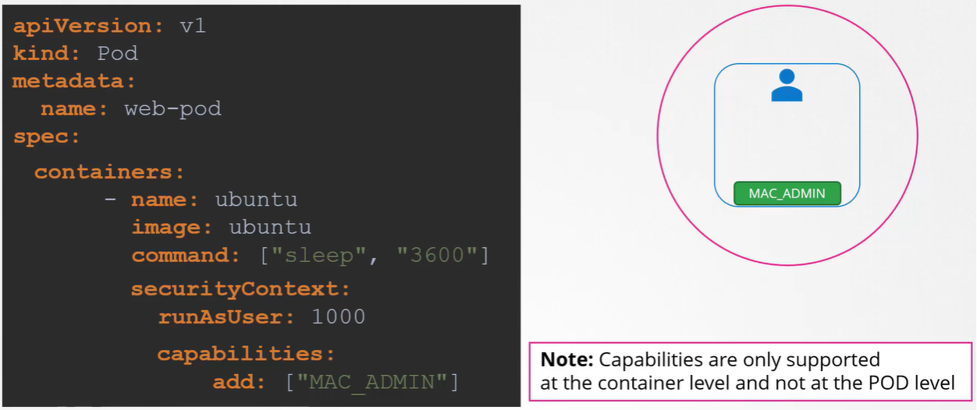

Admission Controllers

RBAC(Role based access control) Restriction

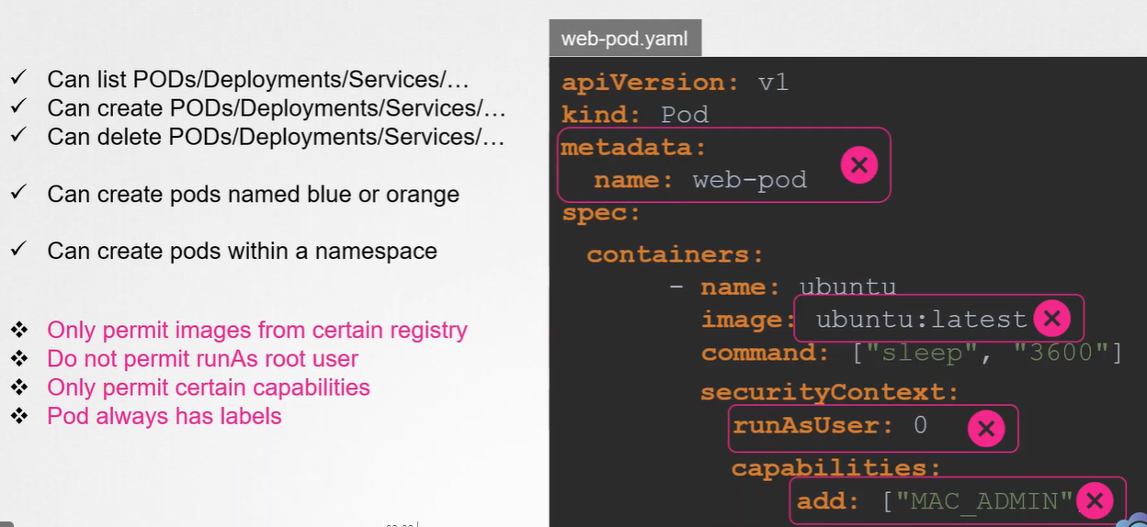

Therefore, we need admission controllers

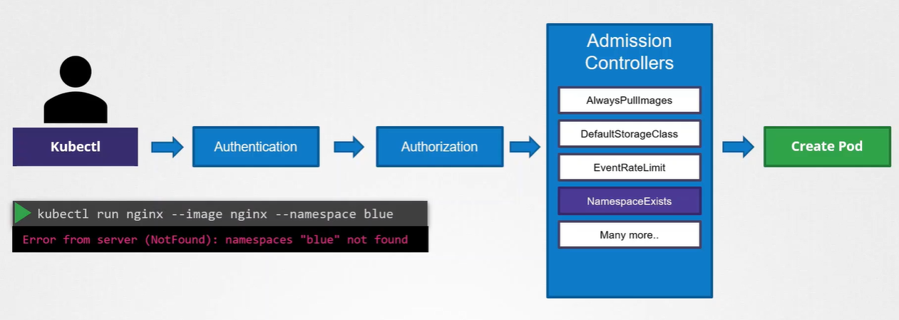

View enabled admission controllers

kube-apiserver –h | grep enable-admission-plugins

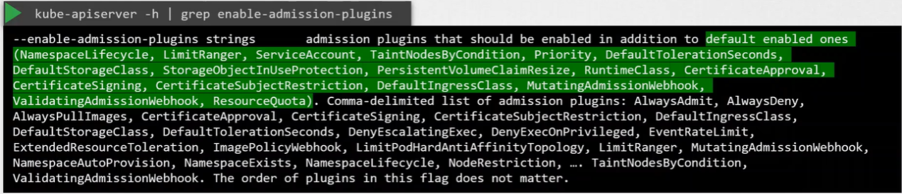

Enable & Disable Admission Controllers

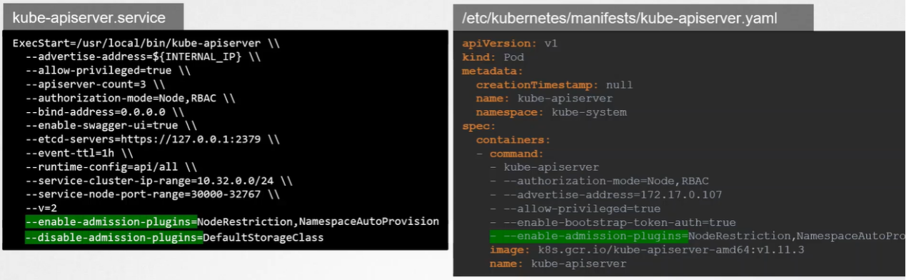

**The type of admission controller**

1. Validating Admission Controller

It can help validate if the object already exists and reject the request if it doesn’t exist.

1. Mutating Admission Controller

It can change or mutate the object itself before it is created

eg. StorageClass

1. Both

Mutating admission controller(NamespaceAutoProvision) ==> Validating admission controller(NamespaceExists)

**Customer Defined admission Controller**

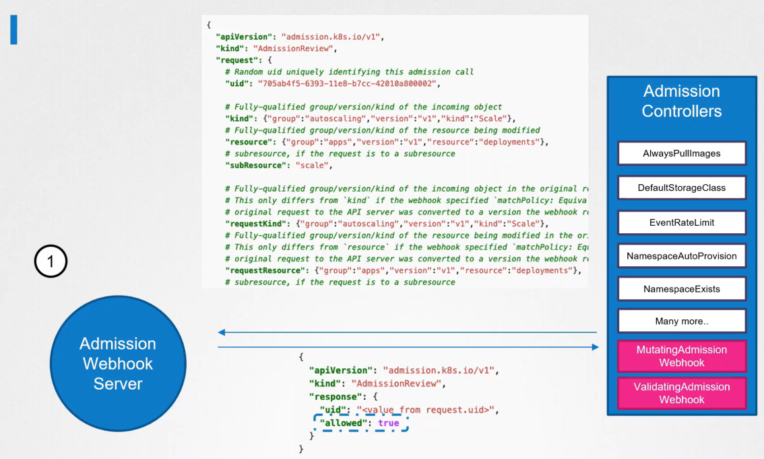

1. Validating Admission Controller Webhook

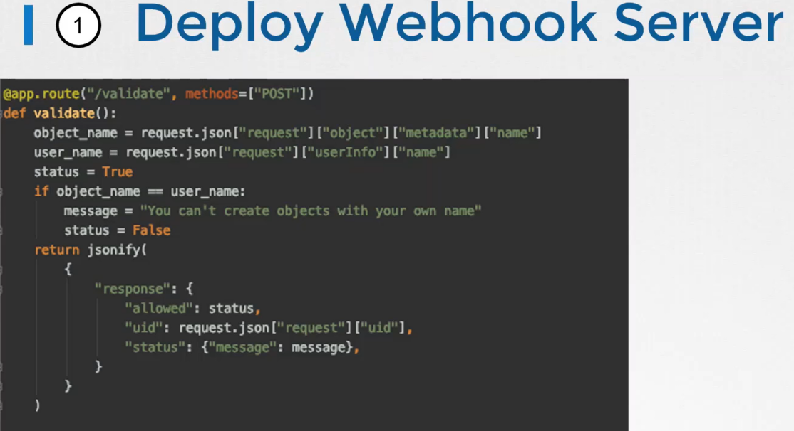

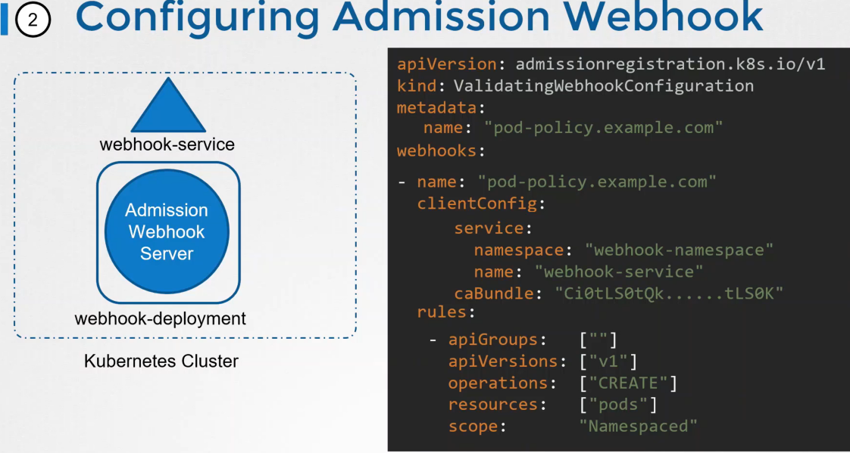

1. Mutating Admission Controller Webhook

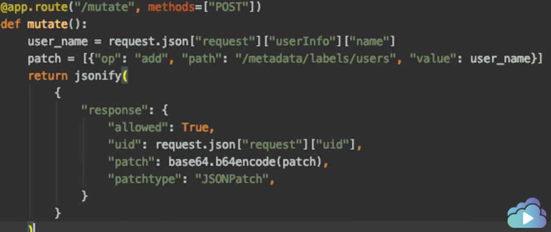

<https://docs.giantswarm.io/advanced/custom-admission-controller/>

1. Image Policy Webhook

<https://stackoverflow.com/questions/54463125/how-to-reject-docker-registries-in-kubernetes>